Name: Pooja Nakar

Student Id: C0727416

Term 3

**TTC Subway Delay Analysis Report**

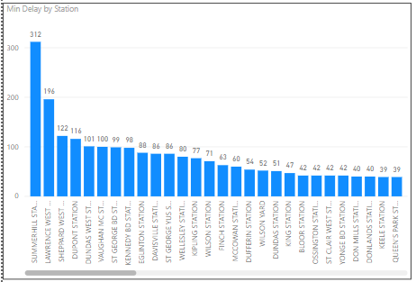

The above chart shows that the station ‘Summerhill Station’ has the maximum delay of trains. Other stations showing the delay times respectively.

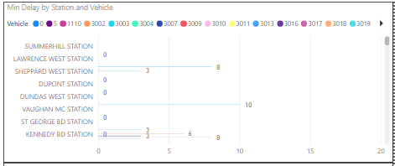

Her we can see the delay time with respect to the stations as well as the vehicle halting at the stations.

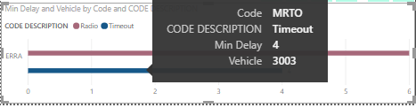

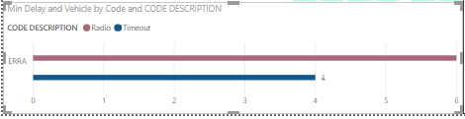

Here we can see vehicle 3003 has been delayed twice with their respective reasons mentioned in the chart as code description.

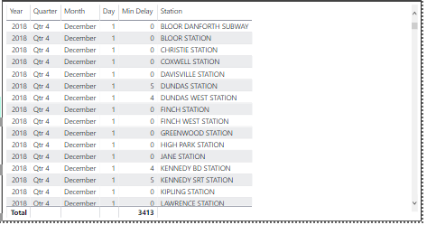

This table has a description of all stations with their delay time, the day, month, and the year of delay.